SEMESTER 1 CHEMISTRY PROJECT: Part 2 Earth Composition Lab

Applying Occam’s Razor to determine the earth’s internal structure:

We talked about the earth’s layers and as the layers naturally move from a state of order to disorder energy is released. This energy can be expressed in the form of earthquakes on the surface. But how can we actually say that the earth is layered and not homogeneous?
Occam’s Razor is a principle that states “all other things being equal, the simplest solution is the best.” We are going to apply this principle to test our hypothesis. After all, the simplest solution would be to assume that the earth is homogeneous-a structure similar to the crust we stand on extends to the core!
In this lab, we will check the evidence to determine if that is true!
Introduction
Watch the following introduction video:

Published on Dec 2, 2016
This animation shows every recorded earthquake in sequence as they occurred from January 1, 2001, through December 31, 2015, at a rate of 30 days per second. The earthquake hypocenters first appear as flashes then remain as colored circles before shrinking with time so as not to obscure subsequent earthquakes. The size of the circle represents the earthquake magnitude while the color represents its depth within the earth. At the end of the animation it will first show all quakes in this 15-year period. Next, it will show only those earthquakes greater than magnitude 6.5, the smallest earthquake size known to make a tsunami. Finally it will only show those earthquakes with magnitudes of magnitude 8.0 or larger, the “great” earthquakes most likely to pose a tsunami threat when they occur under the ocean or near a coastline and when they are shallow within the earth (less than 100 km or 60 mi. deep).
This time period includes some remarkable events. Several large earthquakes caused devastating tsunamis, including 9.1 magnitude in Sumatra (26 December 2004), 8.1 magnitude in Samoa (29 September 2009), 8.8 magnitude in Chile (27 February 2010), and 9.0 magnitude off of Japan (11 March 2011). Like most earthquakes these events occurred at plate boundaries, and truly large events like these tend to occur at subduction zones where tectonic plates collide. Other, much smaller earthquakes also occur away from plate boundaries such as those related to volcanic activity in Hawaii or those related to wastewater injection wells in Oklahoma.

** Pause the video and analyze the information provided in the bottom bar.

- What is the time span represented by the video?
- What do the color of the circles represent?
- What do the size of the circles represent?
- Hypothesize where you believe there will be the most earth quake activity.
- Was your hypothesis correct? Where was the most earth quake activity?
- Do you notice any trends in earthquake activity? Or do they appear to be random?
- Draw on the map below, highlighting the areas with the most earthquake activity.
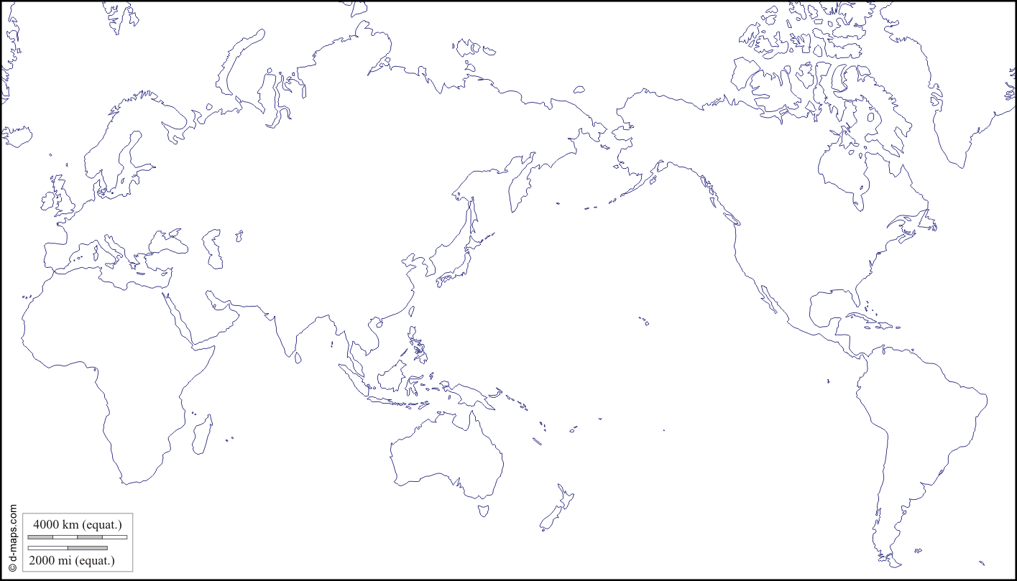

Earth Composition Lab
Step 1: Solve for the theoretical time it takes seismic waves to travel.

We know that it takes approximately 11km/s for seismic waves to travel through rock. We can use this measurement to calculate the time it should take for earthquake waves to arrive at various places around the earth. Use the scale model of Earth to calculate the theoretical arrival time for each station.
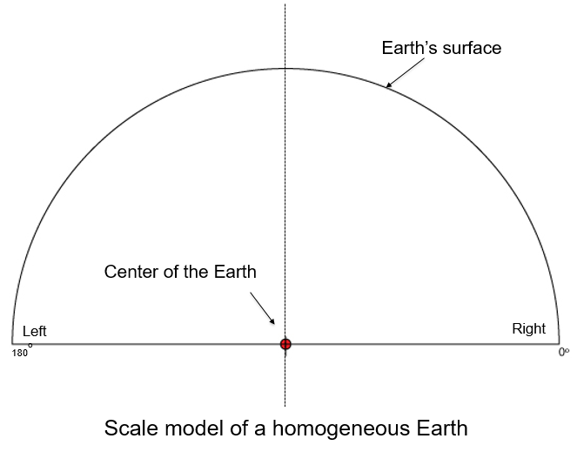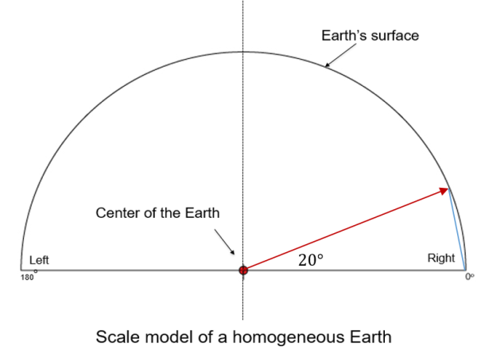

- Use a protractor to measure each angle from the ‘Center of the Earth’ to where it intersects the ‘Earth’s surface’. Represented by the red line.
- Draw a line to connect the 0° point to the ‘Earth’s surface’ intersection point. This is represented by the blue line.
- Measure and record the distance from the 0° point to the ‘Earth’s surface’ intersection point (blue line) in cm and record in column B on the data table.
- Repeat for all given degrees of measurement.
- Multiply each value found in column B by the scale factor of 320km/cm to find the total distance on Earth in kilometers.
- Divide the value you found for column C by 11km/s to find the theoretical time it would take seismic waves to travel that distance through rock.
- Divide your value in column D by 60s to solve for the total time minutes.

A | B | C | D | E
Station location in degrees. | Distance from 0° point to the ‘Earth’s surface’ intersection point. (cm) | Actual distance traveled in through the earth. (km)  (Column B x 320km/cm) | Theoretical travel time. (sec)  (Column C / 11km/s) | Travel time.  (min)  (Column D / 60s)
5
20
40
60
80
100
120
140
160

Step 2: Record data on the actual time it took seismic waves to travel.
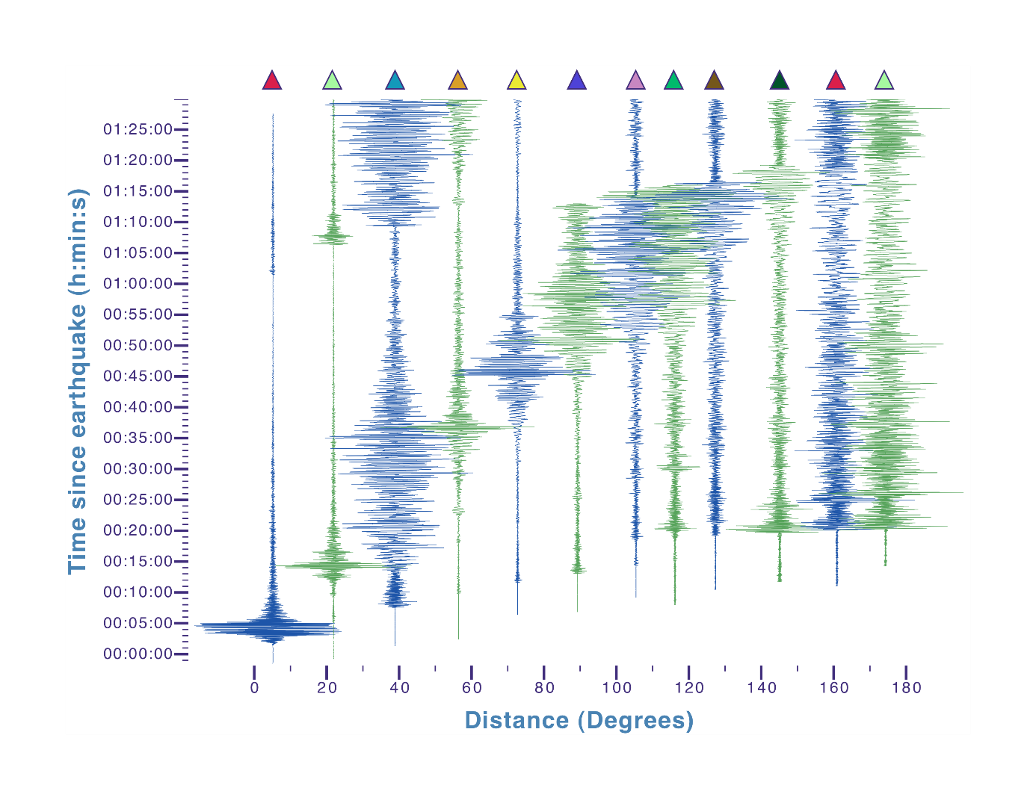
- Using the above image of seismograms, record the distance in degrees from the epicenter or 0°.
- Using the above image of seismograms, record the approximate start of significant seismic activity for each event.

Step 3: Data analysis.

- Plot your first set of data calculated in step 1 in the data table below. Draw a circle to represent the time it is expected to take seismic ways to arrive at each of the degrees you calculated.
- Plot your second set of data calculated in step 2 in the data table below. Draw a triangle to represent the time it actually took seismic waves to arrive at each of the degrees represented by a seismogram.

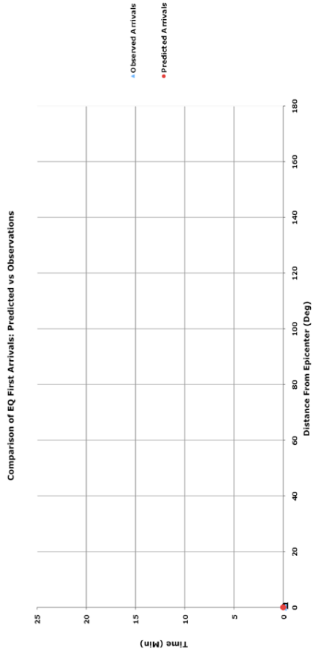
- Were the expected results and the observed results the same? Identify exact places where there is a discrepancy in the data.

- If we know that seismic waves travel through rock at 11 km/s what is an explanation for why the observed times do not match up with the expected times?

Project adapted from Incorporated Research Institution of Seismology, http://www.iris.edu.

To fully explain the discrepancies found in the activity we need to examine the composition of the earth.
- Research and create a diagram that shows the complexity of the earth, your diagram must:
- Label the: crust, mantle, outer core, and inner core, as well as the lithosphere and asthenosphere.
- Indicate which layers are liquid or ridged.
- Identify the major components of each layer.

- Draw and label a normal, reverse and strike slip fault. Include arrows that indicate the direction of movement and give an example of where each of these faults occur.

Site any online or text sources you looked up to assist you in drawing the above models.

Project Summary 2
Write a paragraph explaining in detail the composition of the earth and how scientists discovered this with the use of earthquakes. Site evidence from the Earth Composition Lab to support your reasoning. Be sure to include numerical facts on the depth and composition of each layer. Site any outside sources you used in reference to drawing your model of the earth.

