SEMESTER 1 CHEMISTRY PROJECT: Part 3

Energy of an Earthquake
The earth has a massive amount of energy stored inside of it and it releases that energy in small spurts as earthquakes. We can calculate the total energy released from each earthquake.
Use the following equation to solve for the total seismic energy radiated from the source of the earthquake using a given magnitude.
E=1011.8+1.5m
Example:

Solve for the total energy released in a magnitude 4.0 earthquake.
E=1011.8+1.5(4.0)  E=1011.8+6  E=1017.8  E=6.31 ×1017 | Substitute 4.0 for m  Multiply 1.5 and 4 to get 6.  Add exponents to get 17.8  Express answer in scientific notation.
This answer is in erg’s a unit of energy and work equal to 10-7 joules.
Convert your final answer to joules.
6.31 ×10171 ×107  6.31 ×1010 | Divide your answer by 1 ×107  Simplify like terms.
The seismic energy in waves radiated from earthquake source is
6.31 ×1010 joules

Step 1: Calculate the energy expenditure for each magnitude given:

Magnitude | Energy in Joules
1
2
3
4
5
6
7
8
9

Magnitude Comparison
With the large amounts of energy released in earthquakes it’s hard to compare it to real life events. Create a diagram below with all 9 magnitudes you calculated and other large energy events placed where they compare on the scale. Your diagram can look like a timeline, graph or any other visual representation of the scale of these events.

Include:
The 9 magnitudes you calculated.
Examples of real earthquakes and where they placed on the scale.
Other man made or natural disasters with large energy outputs, example: the atomic bomb or a tornado.

Earthquake Data
Apply what you have learned to real live earthquake data using earthquake.usgs.gov. Follow the steps below to download the data onto your tablet or computer.
- Visit the following website:  https://earthquake.usgs.gov  Click on “Latest Earthquakes”. | - Select the gear icon on the top right.
- Select 7 Days, All Magnitudes U.S. | • Click the drop down that states how many earthquakes are shown.
- Click “Download Earthquakes” | • Select the CVS file.
At this point the data will apear in a spread sheet.
If you are using a iPad it will apear in a pop up over your screen. If you are using a PC look in the lower left corner of the window. If you are using a Mac look for the Downloads button on the top right.

Computer

Excel
When you open the file it will automatically open in excel. Highlight the column with information on magnitudes by clicking the letter above ‘mag’. On the bottom right of the sheet the information for average, total count will appear.
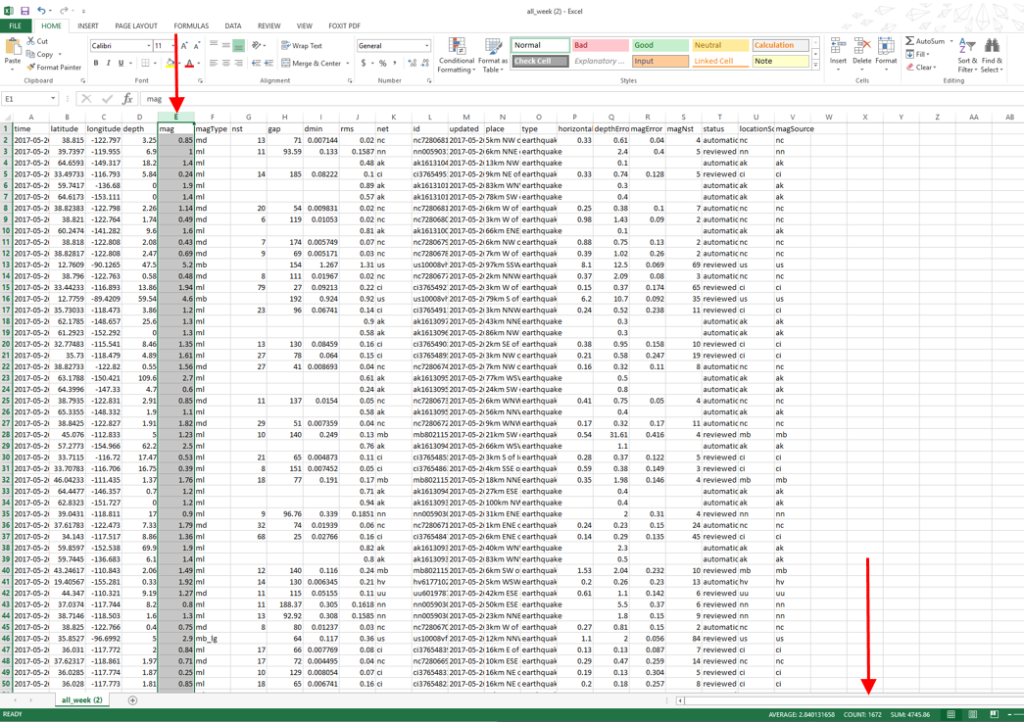

Select the entire spread sheet by clicking on the box in the top left by the 1 and A. Then Select the ‘Sort and filter’ option and ‘Custom filter’ | Sort by ‘mag’ and ‘Largest to smallest’ | Now the data is organized by the size of the earthquake. Highlight all earthquakes that fall into the magnitude spans below and record the total count.

Binomial Probability of an Earthquake
For this assignment you will collect data on the

CCSS.MATH.CONTENT.HSS.CP.B.9
(+) Use permutations and combinations to compute probabilities of compound events and solve problems.
For your set of data record the following:

What is the total count of earthquakes over 7 days: ____
What was the average magnitude over the 7 days: ______
What was the average energy released by an earthquake recorded in the 7 days (use average magnitude): ______
What was the energy released by the largest earthquake recorded in the 7 days: ______

- Count the earthquakes that fall into each magnitude range.
- Calculate p, the percentage of each magnitude occurred in the 7 day trial.
- Calculate q, the percentage of each magnitude not occurring in the 7 day trial.

Magnitude | Earthquake count in this magnitude | % it occurred in the 7 day trial.  (p=Count in this magnitude rangeTotal count of earthquakes) | % of it not occurring in the 7 day trial.  (q=100-p)
- – 1.99
- – 2.99
- – 3.99
- - 4.99
- – 5.99
- - 6.99
- - 7.99
- – 8.99
- – 9.99

Binomial Probability of an Earthquake

Use the data you calculated and the equation 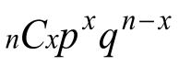to solve for the probably that a certain magnitude range will occur a given amount of times x in a given time period n.

n | The numbers of trials
x | Probability of success in a given set of trials
p | Probability of success in known data
q | Probability of failure in known data

Example: If your study finds that a 6.0-6.99 earthquake made up 10% of the total earthquakes in a week, which would mean that it didn’t occur 90% of the times there was an earthquake. Calculate the probability that an earthquake with a magnitude of 6.0-6.99 would occur on 2 out of the next 7 days.

 | Substitute variables with correct terms.
https://www.desmos.com/scientific | Access a scientific calculator via desmos.
 | Select the function ‘func’ option to change the keyboard and click on the button.
Enter your variable in the equation following the sample show.

Your answer will appear to the right of your equation.

Convert your answer to a percentage and write a complete sentence to express what it means.
Using the data from the 7 day trail, there is approximately a 12% probability that an earthquake 6.0-6.99 will occur 2 out of the next 7 days.

Binomial Probability of an Earthquake
Using your data, solve for the probability that an earthquake with a magnitude 4.0-4.99 will occur 2 out of the next 7 days.

Using your data, solve for the probability that an earthquake with a magnitude 4.0-4.99 will occur 5 out of the next 7 days.

How did the probability change between a magnitude 4.0-4.99 earthquake occurring 2 versus 5 of the next 7 days? Are these the results you expected to get? Why?

Using your data, solve for the probability that an earthquake with a magnitude 5.0-5.99 will occur 2 out of the next 7 days.

Using your data, solve for the probability that an earthquake with a magnitude 2.0-2.99 will occur 2 out of the next 7 days.

How did the probability change between a magnitude earthquake 5.0-5.99 and 2.0-2.99 occurring 2 of the next 7 days? Are these the results you expected to get? Why?

Pose a question on your own and solve for the probability.

Project Summary 3
Write a paragraph explaining in detail the probability of different magnitude earthquakes happening. How can this be used to calculate the probability of a large earthquake occurring? Use numerical data from your Energy of an Earthquake activity and Binomial Probability of an Earthquake lab to support your answers. Site any outside sources used.

